1. Consider this ERD for create Employee and Department table:

* Create table Department based on following datatype and constraint.
* Deptno should auto increment
* Deptno should start with 101

|  |  |  |
| --- | --- | --- |
| **Department** | | |
| Deptno | Int | Primary key |
| Deptname | Varchar(30) | Not null |
| Location | Varchar(20) | Not null |

* Create table Employee based on following datatype and constraint.
* Emp_Id should auto increment
* Emp_Id should start with 1

|  |  |  |
| --- | --- | --- |
| **Employee** | | |
| Emp_Id | Int | Primary Key |
| Fname | Varchar(10) | Not null |
| Lname | Varchar(10) | Not null |
| Email | Varchar(30) | Not null |
| Joining_Date | Datetime |  |
| Deptno | Int | Foreign key |

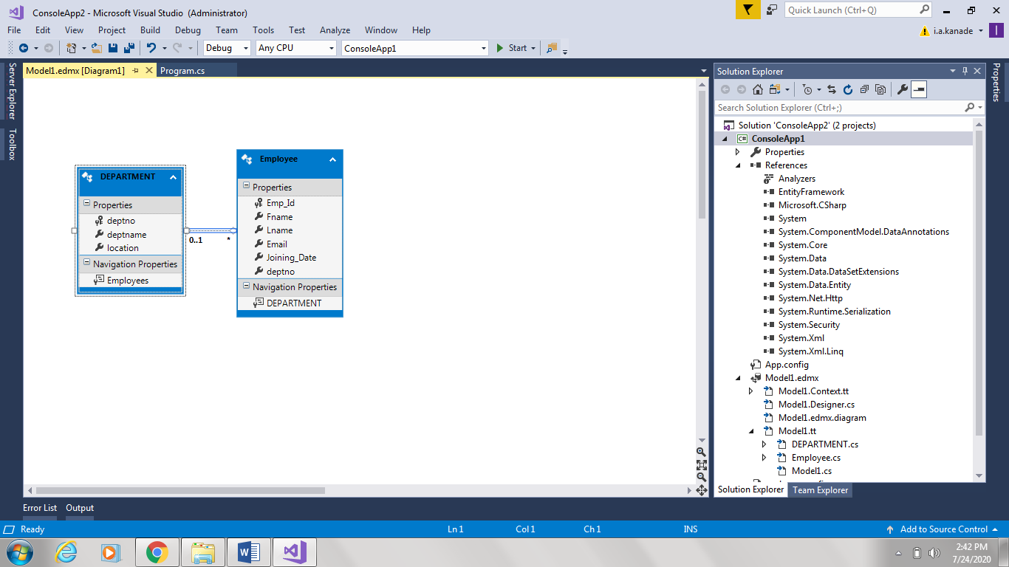

1. Add records in Department and Employee table as below

Department Table :

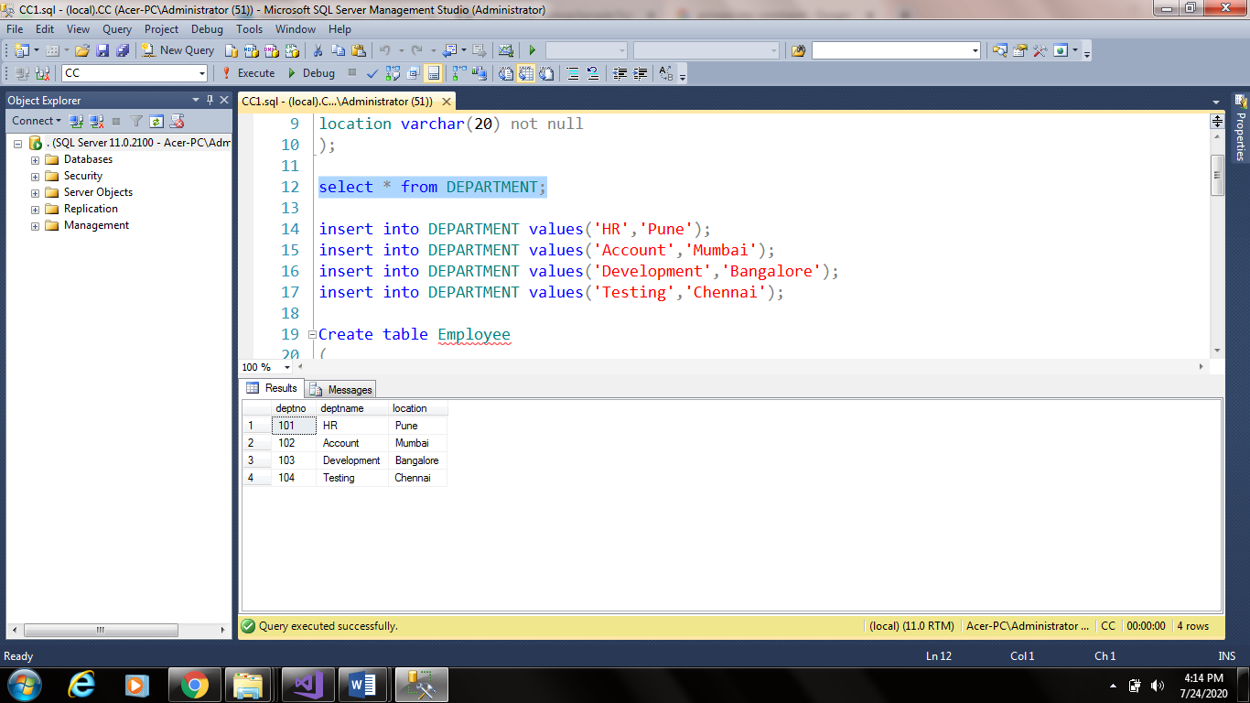

Employee Table :

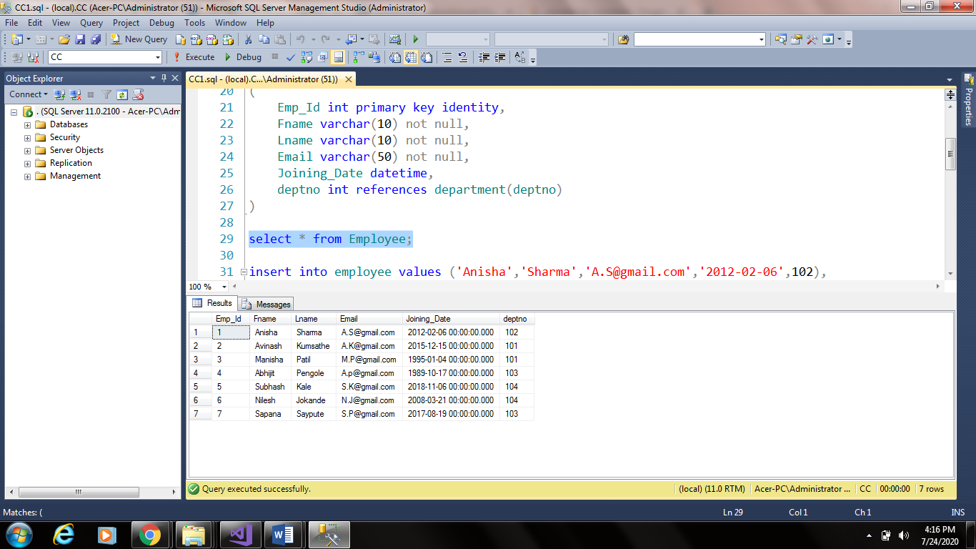

1. The Application team is in need of a query which is expected to display the output as follows:
2. Create function “Calculate_Experience” which has one parameter “@DateValue datetime” to calculate numbers of years experiences.
3. Join Fname and Lname column data as “Name”
4. Date of Joining data should be in following format “Day of the week, Day Month, Year”
5. Calculate Experience in years by using function “Calculate_Experience”.

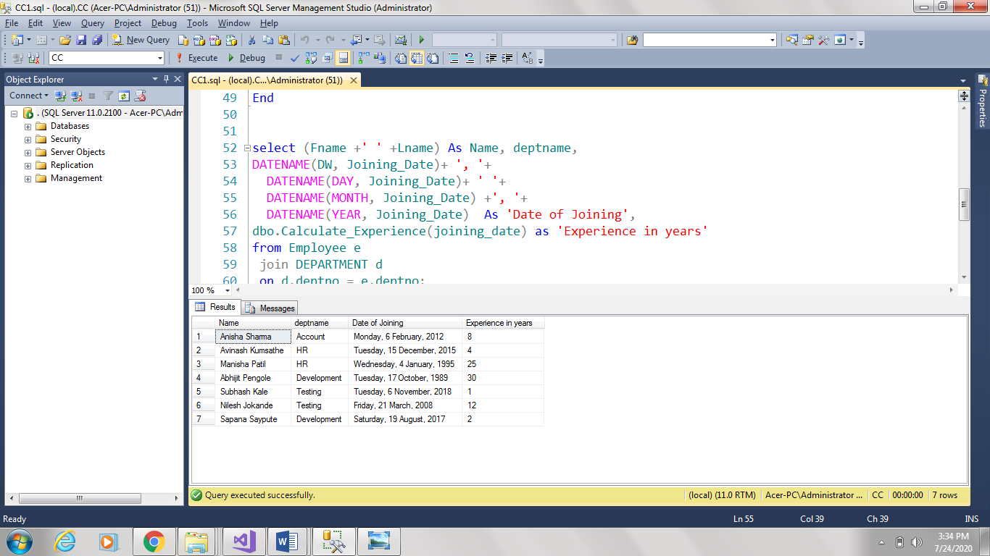

1. Write query which fulfill following condition :
2. Join Fname and Lname column data as ‘Name’
3. Display Department name which based on deptno.
4. Calculate Experience in years by using function “Calculate_Experience”.
5. If experience is more than 5 then display message “Eligible for Gratuity” otherwise message should be “Not Eligible for Gratuity”. Tip : Use Case Statement

